**Project 3: Healthcare Predictive Analytics Project**

**v1.0**

**GitHub link:** [**aldwaltly/DEBI-Project**](https://github.com/aldwaltly/DEBI-Project)

|  |  |
| --- | --- |
| Student name | Student ID |
| Youssef Mohamed Mohamed | **21064291** |
| Mohamed Mahmoud Hussein | **21064445** |
| Ahmed Wael Mohamed | **21095708** |
| Abdelrahman Ahmed Samir | **21066553** |
| Moustafa Hamdy Mohamed | **21093187** |
| Amr Yasser Hamdan | **21074207** |

Contents

Project Planning & Management 3

1. Project Proposal 3

2. Project Plan 4

3. Task Assignment & Roles 5

4. Risk Assessment & Mitigation Plan 5

5. Key Performance Indicators (KPIs) for a Diabetes Prediction Model 6

Literature Review 6

Requirements Gathering 6

1. Stakeholder analysis 6

2. User Stories & Use Cases 7

3. Functional Requirements 8

4. Non-Functional Requirements 9

System Analysis & Design 9

1. Problem Statement & Objectives – Define the problem being solved and project goals. 9

2. Database Design & Data Modeling 11

3. Data Flow & System Behavior 13

4. UI/UX Design & Prototyping 16

5. System Deployment & Integration 17

# Project Planning & Management

## Project Proposal

This project focuses on developing a predictive model for diabetes diagnosis based on a dataset containing relevant health parameters. The goal is to leverage machine learning techniques to predict whether an individual is likely to have diabetes, using medical and demographic data.

Objectives

1. Data Understanding & Preprocessing
   * Analyze the dataset structure and features.
   * Handle missing values, outliers, and data imbalances.
   * Perform feature selection and engineering to enhance model performance.
2. Exploratory Data Analysis (EDA)
   * Identify patterns and correlations between features.
   * Visualize distributions and trends in diabetic vs. non-diabetic patients.
3. Model Development
   * Train multiple machine learning models (e.g., Logistic Regression, Decision Trees, Random Forest, SVM, and Neural Networks).
   * Optimize model parameters using hyperparameter tuning.
   * Evaluate models using performance metrics (e.g., accuracy, precision, recall, F1-score, ROC-AUC).
4. Deployment & Interpretation
   * Develop a user-friendly interface for predictions.
   * Interpret model results to provide actionable insights for healthcare professionals.

Scope of the Project

* Dataset: The project will use structured medical data, such as the PIMA Indian Diabetes Dataset or any other relevant diabetes dataset.
* Features Considered: Age, BMI, blood pressure, glucose levels, insulin levels, skin thickness, pregnancy count, and family history of diabetes.
* Outcome Variable: Binary classification – Diabetic (1) or Non-Diabetic (0).
* Target Audience: Healthcare practitioners, data scientists, and medical researchers aiming to leverage AI for early diabetes detection.

## Project Plan

Figure Gnatt chart

|  |  |
| --- | --- |
| Milestone | Key Deliverables |
| 1. Data Collection, Exploration & Preprocessing | EDA Report, Interactive Visualizations, Cleaned Dataset |
| 2. Data Analysis, Visualization & Feature Engineering | Data Analysis Report, Visualizations of Health Trends, Feature Engineering Summary |
| 3. Model Development & Optimization | Model Evaluation Report, Model Code, Final Model |
| 4. MLOps, Deployment & Monitoring | Deployed Model, MLOps Report, Monitoring Setup |
| 5. Final Documentation & Presentation | Final Project Report, Final Presentation |

**Resource Allocation**

**1. Human Resources**

|  |  |  |
| --- | --- | --- |
| Role | Responsibilities | Estimated Effort |
| Data Scientist | Data preprocessing, feature engineering, model development, and evaluation | 40% |
| Machine Learning Engineer | Model optimization, deployment, and API development | 25% |
| Data Analyst | Exploratory Data Analysis (EDA), visualization, and insights generation | 15% |
| Software Developer | Frontend/backend development for user-friendly implementation | 10% |
| Project Manager | Overseeing the project timeline, resource allocation, and coordination | 10% |

**2. Data Resources**

|  |  |
| --- | --- |
| Resource | Description |
| Dataset | [Diabetes prediction dataset](https://www.kaggle.com/datasets/iammustafatz/diabetes-prediction-dataset) |
| Feature Selection | glucose level, BMI, age, Smoking history, etc. |

## Task Assignment & Roles

|  |  |
| --- | --- |
| Team member | Role & Assignment |
| Mohamed Mahmoud (Leader) | Project management, Model Training, Optimization & Task Coordination |
| Abdelrahman Ahmed | Model Tuning & Hyperparameter Optimization |
| Youssef Mohamed | Deployment & AI Development |
| Ahmed Wael | Model Evaluation & Performance Metrics |
| Amr Yasser | Exploratory Data Analysis (EDA) & Visualization |
| Moustafa Hamdy | Data Preprocessing & Feature Engineering |

## Risk Assessment & Mitigation Plan

|  |  |  |
| --- | --- | --- |
| Risk | Impact | Mitigation Strategy |
| Data Quality Issues (e.g., missing or biased data) | Poor model accuracy | Perform data preprocessing (imputation, outlier removal) and use a diverse dataset. |
| Overfitting (model performs well on training but poorly on real-world data) | Poor generalization to new patients | Use cross-validation, regularization (L1/L2), and dropout layers (for neural networks). |
| Class Imbalance (e.g., more non-diabetic samples than diabetic) | Model favors majority class | Use SMOTE (Synthetic Minority Over-sampling Technique) or adjust class weights. |

## Key Performance Indicators (KPIs) for a Diabetes Prediction Model

For a machine learning model predicting diabetes, relevant KPIs focus on accuracy, reliability, and fairness.

**1. Model Performance KPIs**

* **Accuracy** → Percentage of correctly predicted cases.
* **Precision & Recall** → Measures false positives and false negatives.
* **F1-Score** → Balances precision and recall.
* **Confusion Matrix** → Measures true positive rate vs. false positive rate.
* **Inference Time** → Speed of making predictions (important if deployed).

**2. Data & Fairness KPIs**

* **Class Balance Score** → Checks if the model is fair across diabetic/non-diabetic groups.

# Literature Review

The literature said “Overall the project planning seems good but choose a good use case for the project as the dataset does not have many features. Also, work on the format and font of the document to make it more professional”. We told him about our use case which is using the model as a predictive system for diabetes diagnosis. He replied, “OK that seems good go ahead and continue working on the project”.

# Requirements Gathering

## Stakeholder analysis

|  |  |  |
| --- | --- | --- |
| Stakeholder | Role | Needs/Expectations |
| Patients (End Users) | Individuals using the system for self-assessment | Accurate predictions, easy-to-use interface, privacy of health data |
| Doctors & Healthcare Providers | Use predictions to support diagnosis | Reliable predictions, interpretable insights, integration with medical records |
| Data Scientists & Developers | Build & improve the model | Access to quality data, model interpretability, system scalability |
| Healthcare Institutions | Hospitals, clinics, research centers | Reduce misdiagnoses, improve patient care, cost-effective deployment |

## User Stories & Use Cases

**User Stories**

|  |  |  |
| --- | --- | --- |
| ID | User Role | User Story |
| US01 | Patient | As a patient, I want to input my medical data and receive a diabetes risk prediction so that I can take preventive actions. |
| US02 | Patient | As a patient, I want to see recommendations based on my risk level so that I can improve my lifestyle. |
| US03 | Patient | As a patient, I want my data to be securely stored so that my privacy is protected. |
| US04 | Doctor | As a doctor, I want to review my patient’s diabetes risk scores so that I can make informed medical decisions. |
| US05 | Data Scientist | As a data scientist, I want to analyze model performance on different demographics so that I can improve its accuracy. |
| US06 | Data Scientist | As a data scientist, I want access to high-quality, well-labeled data so that I can train a reliable model. |

**Use Cases**

**Use Case 1: Patient Checking Diabetes Risk**

**Actors:** Patient, System (Diabetes Prediction Model)  
**Preconditions:**

* The patient has access to the system.
* The patient is willing to input required health data.

**Steps:**

1. The patient opens the application.
2. The patient enters personal and health-related data (age, BMI, glucose level, etc.).
3. The system processes the data and runs the prediction model.
4. The system displays the risk level (Low, Medium, High) with confidence score.

**Postconditions:**

* The patient receives diabetes risk assessment.
* The patient can take preventive measures or consult a doctor.

**Use Case 2: Data Scientist Improving Model Accuracy**

**Actors:** Data Scientist, System, Patient Data  
**Preconditions:**

* The data scientist has access to anonymized patient data.
* The system logs model performance over time.

**Steps:**

1. The data scientist loads recent patient data and model predictions.
2. The data scientist analyzes model accuracy, biases, and feature importance.
3. The data scientist retrains the model with additional data if needed.
4. The system updates the model with the improved version.
5. The data scientist tests the updated model for better accuracy and fairness.

**Postconditions:**

* The model is improved based on new data.
* The system provides more reliable predictions.

**Use Case 3: Healthcare Administrator Monitoring System Usage**

**Actors:** Healthcare Administrator, System  
**Preconditions:**

* The system has been deployed in a hospital or clinic.
* The administrator has access to performance reports.

**Steps:**

1. The administrator logs into the system.
2. The system displays usage statistics (number of predictions, accuracy trends).
3. The administrator reviews system performance and patient feedback.
4. The administrator decides on further actions (e.g., expanding system use).

**Postconditions:**

* The administrator ensures the system is beneficial and compliant.
* The hospital improves patient care with AI-driven insights.

## Functional Requirements

|  |  |
| --- | --- |
| Requirement ID | Requirement Statements |
| FR1 | Import, normalize, and automate the cleaning and preprocessing of the data. Handle missing values and outliers. The data should be anonymized to ensure privacy. |
| FR2 | Perform data analysis to identify trends and patterns. Use statistical methods such as correlation analysis, hypothesis testing, or feature importance analysis to identify key factors affecting healthcare outcomes. |
| FR3 | Show visualizations to highlight trends, outliers, and significant patterns in health metrics. It also should include an interactive and responsive dashboard to easily view the data. |
| FR4 | Implement the best ML model for the data, split the data into training, validation, and testing, and tune hyperparameters. |
| FR5 | Calculate the performance matrices such as accuracy, F1-score, AUC-ROC, precision, and recall, and evaluate confusion matrix. |
| FR6 | Deploy the model as a REST API or web service accessible to professionals. Implement MLOps practices for versioning, experiment tracking, and reproducibility. |
| FR7 | Set-up continuous monitoring to detect model drift or performance degradation over time and alerts for retraining or updating models based on incoming data or decreased accuracy. |

## Non-Functional Requirements

|  |  |
| --- | --- |
| Measure | Details |
| Performance | The prediction should have low latency (minimum delay) to ensure real time or near real time response. |
| Usability | Have a user-friendly dashboard for users and support interactive visualization. |
| Reliability & Availability | The system has continuous monitoring and implements alerts to target a system availability of 99.99% |
| Security & Privacy | Implement access controls and authentication and anonymize patient’s data. |
| Maintainability | Implement modular design and apply version control practices for easier updates, integration, and prevent unintended errors. |

# System Analysis & Design

## Problem Statement & Objectives – Define the problem being solved and project goals.

**Problem Statement**

Traditional healthcare systems rely on manual data analysis for diagnosing diseases like **diabetes**, which can lead to delays in medical decisions. By integrating **machine learning (ML)** with a **web-based system**, we can provide **fast and accurate predictions**, assisting patients and doctors in early detection and treatment.

**Objectives**

* Develop a machine learning model to predict diabetes based on medical data.
* Build a web-based platform where patients can enter their medical records.
* Provide interactive graphs and reports for a better understanding of the results.
* Ensure data security and privacy compliance.

**Use case Diagram & Descriptions**

**Use Case Diagram**

The system will have three main actors:

* Patient – Enters medical data and views results.
* ML Model – Analyzes data and generates predictions.
* System (Website) – Handles user interaction, sends data to the model, and displays results.

**Use Case Descriptions**

Use Case: Diabetes Prediction

* Actor: Patient
* Preconditions: The patient must provide all required medical inputs.
* Steps:
  1. The patient enters medical data (glucose level, BMI, age, etc.).
  2. The website sends data to the ML Model.
  3. The model processes the input and returns a prediction.
  4. The system displays the result as a graph and a message indicating whether the patient is at risk for diabetes.
* Expected Outcome: The patient receives a clear, data-driven diagnosis.

Figure Use Case Diagram

**Functional & Non-Functional Requirements:**

**Functional Requirements:**

|  |  |
| --- | --- |
| Requirement ID | Requirement Statement |
| FR1 | The website should allow patients to input their medical data. |
| FR2 | The system should send the data to the AI model for prediction. |
| FR3 | The result should be displayed in a graph and a health status message. |
| FR4 | The result should be accurate |
| FR5 | The system should store patient records securely. |

**Non-Functional Requirements:**

|  |  |
| --- | --- |
| Requirement | Requirement Statement |
| Performance | Predictions should be generated in ≤ 3 seconds. |
| Security | Patient data must be encrypted. |
| Scalability | The system should handle large datasets efficiently. |
| Usability | The website should be responsive and user-friendly. |

**Software Architecture**

**Architecture Type:**

We will use MVC (Model-View-Controller) architecture:

* Model: Machine Learning model (predicts diabetes risk).
* View: Website frontend (where patients input data and view results).
* Controller: Backend API (handles requests and connects frontend with ML model).

**System Components:**

Frontend (User Interface) – Built with Angular to create a modern and responsive experience.

Backend (API & Logic Processing) – Developed using Flask or FastAPI to process data and interact with the AI model.

Database (Storage Layer) – Uses PostgreSQL or MongoDB to store patient records securely.

Machine Learning Model – Implemented with Scikit-learn or TensorFlow for predicting diabetes risk.

Figure Use Case Diagram 2

## Database Design & Data Modeling

**1. Introduction**

This document presents the database design and data modeling for the Diabetes Prediction Project. The goal is to structure the database efficiently to store and retrieve patient data, medical parameters, and prediction results while ensuring scalability and data integrity.

**2. Entity-Relationship Diagram (ERD)**

The ERD represents the database structure, showing entities, attributes, and relationships. Key entities include Patients, Medical Tests, Predictions, and Doctors.

**3. Database Schema**

The database consists of the following tables:

**Patients**

* PatientID (Primary Key)
* Name
* Age
* Gender
* FamilyHistory
* ContactInfo

**Medical Tests**

* TestID (Primary Key)
* PatientID (Foreign Key)
* GlucoseLevel
* BMI
* BloodPressure
* InsulinLevel
* SkinThickness
* Pregnancies
* TestDate

**Predictions**

* PredictionID (Primary Key)
* PatientID (Foreign Key)
* TestID (Foreign Key)
* PredictionResult (0: Non-Diabetic, 1: Diabetic)
* ConfidenceScore
* PredictionDate

**Doctors**

* DoctorID (Primary Key)
* Name
* Specialization
* ContactInfo

**4. Normalization**

Normalization is applied to eliminate redundancy and improve data integrity. The tables follow Third Normal Form (3NF) to ensure efficient storage and avoid anomalies.

**5. Justification for Design Choices**

The database design ensures:   
 **Scalability:** Supports a growing dataset efficiently.  
 **Data Integrity:** Foreign keys maintain relationships between tables.  
 **Performance Optimization:** Indexed keys allow fast retrieval of patient records.  
 **Security:** Sensitive data is stored separately to enhance privacy.

## Data Flow & System Behavior

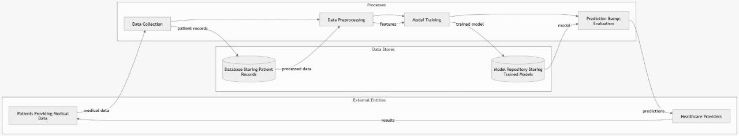

Figure DFD Diagram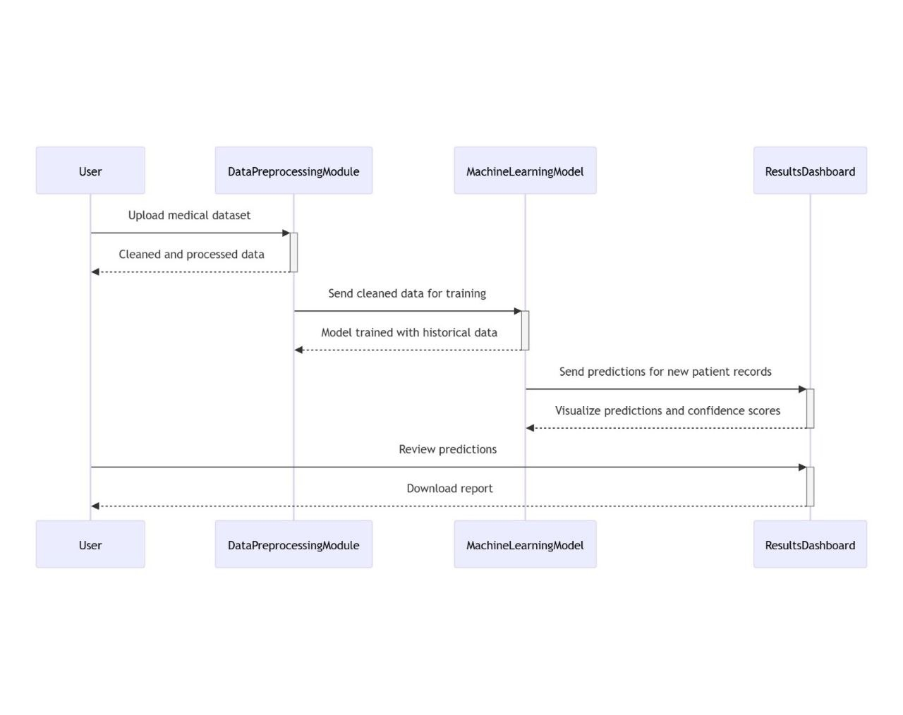Figure Sequence Diagram

Figure State Diagram

Figure Activity Diagram

Figure Class Diagram

## UI/UX Design & Prototyping

Figure UI Design

The above is a system navigation showing how we plan to build the UI. However, we haven’t decided on the actual design, colors, typography, and accessibility yet.

## System Deployment & Integration

**Technology Stack**

A technology stack is a collection of technologies used to create a software application. It includes different layers that work together, from the user-facing interface to the databases and server logic behind the scenes.

**Backend Technologies**

The backend handles the logic, database interactions, user authentication, and communication with servers. It forms the foundation of your application.

* **Flask** – A lightweight and flexible framework, ideal for building machine learning APIs and handling requests efficiently.

**Frontend Technologies**

The frontend is what users see and interact with. It covers the user interface (UI) and user experience (UX).

* **Angular** – A robust framework for building dynamic web applications, providing a structured and scalable approach.

**Database Technologies**

Databases store and manage data for your application. The choice between relational (structured) and non-relational (flexible) databases is critical.

* **MySQL** – Chosen for its reliability, scalability, and ability to handle structured health-related data securely.

**Model Deployment**

* **TensorFlow Serving** – Used to efficiently deploy and manage the predictive model for real-time diabetes risk assessment.

**Deployment Diagram**

The deployment diagram illustrates how different software components are distributed across hardware. It includes:

* **User Interface (Angular Web App):** Hosted on web, allowing users to input data and receive predictions.
* **Backend Server (Flask API):** Deployed on a server, responsible for processing user requests and communicating with the model.
* **Database (MySQL):** Securely hosted on a database server to store user data and predictions.
* **Model Server (TensorFlow Serving):** Handles real-time prediction requests and interacts with the backend API.

**Component Diagram**

The component diagram provides a high-level view of the system's main components and their interactions:

* **Frontend (Angular Web App):** Collects user input and displays results.
* **Backend (Flask API):** Routes requests between the frontend, model, and database.
* **Predictive Model (TensorFlow Serving):** Processes input data and provides diabetes risk predictions.
* **Database (MySQL):** Stores patient data, prediction history, and analytics.
* **Authentication Module:** Ensures secure access to the system, preventing unauthorized use.

**Explanation of Chosen Technologies**

* **Flask:** Chosen because it is lightweight, easy to use, and well-suited for building APIs that handle machine learning models.
* **Angular:** Selected for its ability to create structured, scalable, and interactive web applications with modular components.
* **MySQL:** Preferred for its structured data storage, reliability, and ability to handle large datasets efficiently.
* **TensorFlow Serving:** Ideal for deploying and managing machine learning models in production with low latency and high performance.

This structure ensures a seamless integration of all components, providing a smooth user experience and efficient model deployment.